Paragraph 8.5 MRL Criteria for Industry

Industry can leverage and adapt the DoD MRL criteria to their company processes. The criteria translate easily across both military and commercial application.
A simple step to adapt the tool begins with embedding business vernacular into the criteria that improve the understanding and acceptance of the assessment process. For example, using company vocabulary instead of the DoD terms (e.g., business or engineering Gates instead of Milestones) as depicted in figure 8.4.
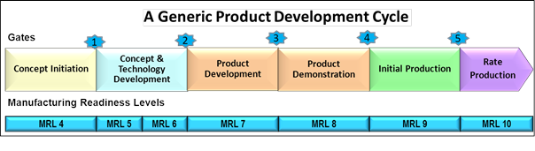
Figure 8.4 – Gated Product Development
To aid in building the manufacturing maturation plan, a company may create a roadmap to follow into the future, emphasizing value added processes instead of identifying what actions were not completed.
A company can embed the complete MRL criteria and assessment process into one spreadsheet or management dashboard. As results are presented and team buy-in increases, improvements are seen by increased productivity. Standardized report out presentation or standardized dashboard formats across the business aids in better upper level management buy-in. When a business assumes ownership of the MRL criteria, it can be concise and controllable allowing for quick resolution of interpretation problems. Ownership also allows lessons learned to be added to the MRL criteria. For example, including an Environmental Health and Service thread, insures that EHS issues are addressed early in the maturation process.
Manufacturing assessments using MRL criteria should be adapted as an integral required element of a company’s new product introduction process. Similar to implementation of ISO 9000/9001 and AS6500, implementation of manufacturing assessments using the MRL criteria to manage risk will improve company operations leading to improved quality, reduced cycle times, reduced costs, and positively impact overall

